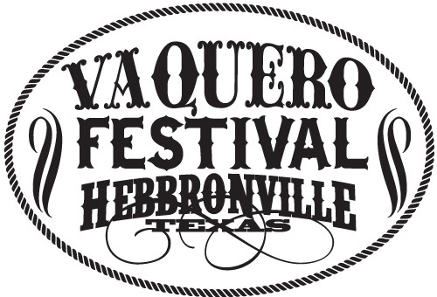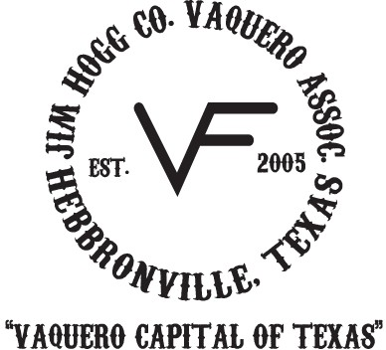PARADE APPLICA,.ION /
RULES & REGULA,.IONS

The Jim Hogg County Vaquero Festival Association is pleased to announce, as part of its festival celebration, our parade on Saturday, November 4, 2 01 7. We are inviting all organizations, groups, businesses, families, and individuals to be a part of this year's Vaquero Festival celebration to honor our vaqueros, past and present, in this traditional parade.

November 4, 2017 -Line-Up Begins at 9am on Longhorn Lane Parade will end at County Fair Grounds
Yes, we would like to participate in the J.H.C. Vaquero Festival Parade which takes place on November 4, 2017,at 1Oam,in Hebbronville, Texas

One entry per application please Deadline for submission of applications Tuesday, October 31, 2011
For more Information please contact: JoAnn Stacy (361) 816-7307
J.H.C. Vaquero Association
P.O. Box 991,Hebbronville,Texas 78361
vaquerofestival®yahoo.com

Name of Business/Club/Organization Total number of persons participating

Contact Person

Type of Entry
Telephone Cell Phone

DFloat DVehicle

DMounted Unit (Equestrian)

DMounted Unit (Motorcycle,etc.)

DBand

DMarching Unit DSchool

Dclub/Organization (Name)---------------------------------­

OOther (Please Describe)----------------------------------

RULES & GUIDELINES FOR PARADE PARTICIPANTS

1. Adult Supervision:
a) A designated "person in Charge"is required to accompany all units.
Units with children under the age of 12 must provide responsible adult supervisors to accompany the unit.
b) All participants, their sponsors,and "person in charge" will immediately comply with any request received from a parade or JHC Vaquero Association Official. The designated "person in charge" will be held responsible for the compliance of the unit as a whole.
c) It is HIGHLY RECOMMENDED THAT CHILDREN UNDER THE AGE OF SIX (6) RIDE ON FLOATS AND NOT WALK/MARCH IN THE PARADE.

2. Alcoholic Beverages:Consumption of any alcoholic beverages or illegal drugs by participants is prohibited.
3. Performance Limitations:Performing of routines is strictly prohibited unless the routine is in a progressives motion.There will be no stopping or pausing along the parade route,No units may perform stunts or maneuvers that may endanger spectators.This includes motor or mini cycle group and Horse units.

Signature

4. Throwing of items during parade:Distribution or throwing of items (including candy, beads and other items) to the crowd must be by ADULT participants and must be in zip lock or small brown paper bags,no loose candy will be allowed. JHCVF officials retain the right to confiscate any said items.
5. Equestrian Entries:Units using horses are required to provide a clean-up crew. The crew should also be available in the line-up area.lf a clean-up crew is not provided,the said entry will be placed at the end of parade.Horse entries must also comply with federal and state quarantine regulations. For more information concerning quarantine,please contact the USDA at (956) 723-3051

6. Flags: Any Flag displayed in conjunction with the parade must confirm to all regulations governing the display of flags in the USA
With this waiver, I accept the full responsibility for any potential accidents that may occur.l will not hold the Jim Hogg County Vaquero Festival Assoc. or any members in charge of this event liable.
Thank You!Hope to Have You As a Part of This Historical Event!

Date

